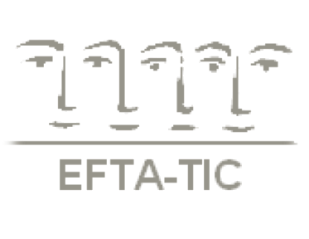

EFTA-TIC Secretariat

[efta-tic@otenet.gr](mailto:efta-tic@otenet.gr) - [www.efta-tic.eu](http://www.efta-tic.eu)

Timisoara, Romania – September 28th- 30th, 2018

**“Love and / in War: Training in Dramatic Times”**

EFTA-TIC Meeting of Trainers

**Abstract Form I**

Abstracts must be submitted in Arial 12 format and not exceed 250 words.

The deadline for submission is **August 1st, 2018**.

Please indicate below which of the following JOINT WORKSHOPS you would like to participate in, together with other institutes:

**[ ] Active Techniques in Couples’ Therapy and Training**

**[ ] Reflective Practices in Supervision and Training in Couple Therapy**

**[ ] Training and Therapy Techniques in Divorce with High Conflict**

**[ ] Integrating Systemic and Attachment Approaches: Working with “War”**

**in Couples’ Therapy and Training**

and say how you intend to promote participation:

………………………………………………………………………………………………………………………………………………………………………………………………………………………………………………………………………………………………………………………………………………

*In the abstract please indicate the relevance of your topic to the overall theme of the meeting.*

**Name of Presenter(s):** ….….………...……………..……………………..…………….………....

**Professional Title:** …….….….………………………………………….…………………………..

**Institute’s Name:** ......…………………………………………………………………………..........

**Abstract:** ….......................................................................................................................................................................................................................................................................................................................................................................................................................................................................................................................................................................................................................................................................................................................................................................................................................................................................................................................................................................................................................................................................................................................................................................………………………………………….…..................................................................................................................................................................................................................................................................................................................................................................................................................................................................................................................................................................................................................................................................................................................................................................................................................................................................................................................................................................................................................................................................................................

*\*The board of EFTA-TIC will select those abstracts that in their opinion best reflect the theme of the meeting.*

*This is to ensure a high quality and coherent programme*

**11th**