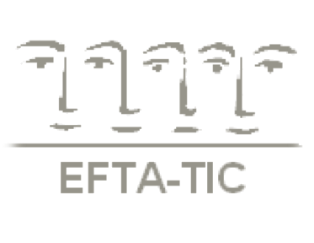

**Abstract Form II**

Abstracts must be submitted in Arial 12 format and not exceed 250 words.

The deadline for submission is **August 1st, 2018**.

Both interactive workshops and written papers are acceptable but the former is the preferred format.

Please indicate below which approach you intend to use:

**[ ] Interactive workshop**

**[ ] Written paper**

and say how you intend to promote participation:

………………………………………………………………………………………………………………………………………………………………………………………………………………………………………………………………………………………………………………………………………………

In the abstract please indicate the relevance of your topic to the overall theme of the meeting.

**Title of Presentation**/**Workshop:** ….......…...…………………………………………………....

……………………….......…...…………………………………………………...………………...…

**Name of Presenter(s):** ….….………...……………..……………………..…………………...…..

**Professional Title:** …….….….………………………………………….………………………….

**Institute’s Name:** ......………………………………………………………………………….........

**Abstract:** ….......................................................................................................................................................................................................................................................................................................................................................................................................................................................................................................................................................................................................................................................................................................................................................................................................................................................................................................................................................................................................................................................................................................................................................................………………………………………….…..................................................................................................................................................................................................................................................................................................................................................................................................................................................................................................................................................................................................................................................................................................................................................................................................................................................................................................................................................................................................................................................................................................

*\*The board of EFTA-TIC will select those abstracts that in their opinion best reflect the theme of the meeting.*

*This is to ensure a high quality and coherent programme*

Timisoara, Romania – September 28th- 30th, 2018

**“Love and / in War: Training in Dramatic Times”**

EFTA-TIC Meeting of Trainers

EFTA-TIC Secretariat – [efta-tic@otenet.gr](mailto:efta-tic@otenet.gr) - [www.efta-tic.eu](http://www.efta-tic.eu)

**11th**