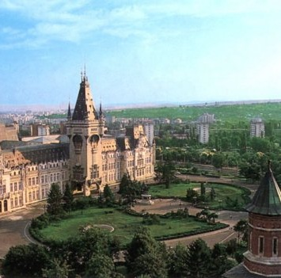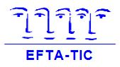**[ ]**

Abstract

Abstracts must be submitted in Arial 12 format and not exceed 250 words.

The deadline for submission has been ***extended to July 11th, 2014***.

Both interactive workshops and written papers are acceptable but the former is the preferred format.

Please indicate below which approach you intend to use:

**[ ] Interactive workshop**

**[ ] Written paper**

and say how you intend to promote participation:

………………………………………………………………………………………………………………………………………………………………………………………………………………………………………………………………

In the abstract please indicate the relevance of your topic to the overall theme of the meeting.

**Title of Presentation**/**Workshop:** ….......…...……………………………………………………………...

…………………………………………………..………………...……………………………………………..

**Name of Presenter:** ….….………...……………..……………………..………………………..................

**Professional Title:** …….….….………………………………………….…………………………………...

**Institute’s Name:** ......…………………………………………………………………………..................…

**Abstract:** ….......................................................................................................................................................................................................................................................................................................................................................................................................................................................................................................................................................................................................................................................................................................................................................................................................................................................................................................................................................................................................................................................................................................................................................................………………………………………….….......................................................................................................................................................................................................................................................................................................................................................................................................................................................................................................................................................................................................................................................................................................................................................................................................................................................................................................................................................................................................................................................................................................................................................................…………………………………………

*\*The board of EFTA-TIC will select those abstracts that in their opinion best reflect the theme of the meeting. This is to ensure a high quality and coherent programme.*

*\*Abstract submissions are limited to 1 per institute so that as many institutes as possible are given the opportunity to present.*

**EUROPEAN FAMILY THERAPY ASSOCIATION - TRAINING INSTITUTES CHAMBER**

Secretariat: 9, Epidavrou St. Halandri – 152 33 Athens – Greece – Tel. +30-697 680 8467 & Fax +30-210-689 84 38 - e-m: [efta-tic@otenet.gr](mailto:efta-tic@otenet.gr)

[www.efta-tic.eu](http://www.efta-tic.eu)

8th EFTA-TIC Meeting of Trainers

September 26th-28th, 2014 - Iasi, Romania

*“Reconciliation of family and professional life in training:*

*experiences and directions”*