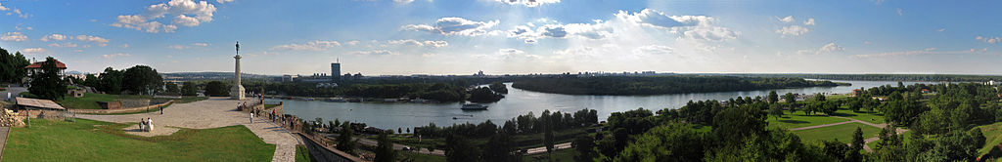

|  |
| --- |
| **Name of Institute** |
|  |
| **Address** |
|  |
| **City** |
| **Code** |
| **Country** |
| **Telephone** |
| **Fax** |
| **E-mail** |
| **Website** |

| Name of the Institute’s representative(s): | |
| --- | --- |
| **Name:** | **Title:** |
| **Name:** | **Title:** |
| **Name:** | **Title:** |
| **Name:** | **Title:** |

Please, send your registration fee by bank transfer directly to:

*EFTA-TIC TREASURY*

*ADDRESS: 1, Rue Jacques Prevert,*

*59650 Villeneuve d'Ascq, FRANCE*

*BANK: Credit du Nord*

*AGENCY: Croix Republique*

*IBAN: FR76 3007 6028 8433 5410 0420 015*

*Code BIC: NORDFRPP*

Kindly make sure that the name of your Institute appears on the payment or send a message confirming your payment to the Treasurer, Michel Maestre: e-mail [michel.maestre@psycom.fr](mailto:michel.maestre@psycom.fr) , fax +33 3 20 05 11

9th Meeting of Trainers

*Embracing New Knowledge*

*Training for Integrative and Innovative Systemic Practice*

Etiam sit amet est

Lorem ipsum dolor sit amet, ligula suspendisse nulla pretium, rhoncus tempor fermentum, enim integer ad vestibulum volutpat. Nisl rhoncus turpis est, vel elit, congue wisi enim nunc ultricies sit, magna tincidunt. Maecenas aliquam maecenas ligula nostra, accumsan taciti. Sociis mauris in integer, a dolor netus non dui aliquet, sagittis felis sodales, dolor sociis mauris, vel eu libero cras. Faucibus at. Arcu habitasse elementum.

Ac dolor ac adipiscing amet bibendum nullam, lacus molestie ut libero nec, diam et, pharetra sodales, feugiat ullamcorper id tempor id vitae. Mauris pretium aliquet, lectus tincidunt. Porttitor mollis imperdiet libero senectus pulvinar. Etiam molestie mauris ligula.

* Donec quis nunc
* Set Ahmet Salem Set
* Donec quis nunc
* Curabitur vulputate viverra pede

When: March 2, 2015

Where: 1234 Main Street  
Anytown, State ZIP

Time: 8am – 3pm

Other: Consectetuer arcu ipsum ornare pellentesque vehicula, in vehicula diam, ornare magna erat felis wisi a risus. Justo fermentum id. Malesuada eleifend, tortor molestie, a a vel et. Mauris at suspendisse, neque a.

123.456.7890

EFTA-TIC Secretariat - 9, Epidavrou Street, 152 33 Halandri, Greece - Tel. +30 6976 808467 Fax. +30 210 6898 438 - [efta-tic@otenet.gr](mailto:efta-tic@otenet.gr) - [www.efta-tic.eu](http://www.efta-tic.eu)

Registration Form

To register for the meeting, please complete and send this form to the EFTA-TIC Secretariat.

To register for the meeting, please complete and send this form to the EFTA-TIC Secretariat.